Suraj Thyagaraj

CWRU Data Analytics Boot Camp

Spring 2020

Module 01-Excel VBA | HW2

Topics Covered: Excel VB, advanced VB

Background

Use VBA scripting to summarize the provided multi-year stock market data. For each year, you are given daily stock prices (open, close, etc.) for all tickers. Compute and display the best and worst performing stocks as well as the most in-demand stocks.

REPORT:

The solution can be found in the excel file: **Multiple_year_stock_data_Solved_ST.xlsm**.

Steps Followed:

For ease of testing, the test code was built to run on the sample data set **alphabetical_testing.xlsx**.

1. Initially created a VB script to work on a single sheet.

2. Initialized the different variables to dynamically store the information of best performing, worst performing and largest volume stocks. These variables were declared appropriately as string, integer or double.

3. Initialized the volume of stock to be zero.

4. Skipping the header row, the first row gives details about the yearly stock open price of the first ticker.

5. Iterating over rows, kept appending the total volume of stock per ticker until the value of ticker (first column) changed. This is where the data for the current ticker ends.

6. The last row per ticker gives details about the yearly stock close price of the first ticker.

7. Before moving to the next ticker, compute the necessary parameters such as yearly change, percent change and total stock volume.

* One issue that was observed later was a ‘Runtime Error 6 Overflow’ error. This was found to occur in instances where the yearly stock open price was Zero, leading to division by zero when computing percent change. This was fixed by adding an 'if' condition.

8. Write the information in a formatted fashion beside the given data as a summary row.

9. Reset the variables and move to the next row to start looking at data for the next ticker.

10. Next step was to repeat the operation over the different worksheets. This was accomplished by putting the entire code within a master loop that goes over each worksheet.

11. To run over the actual data set, the flowchart was still the same, only some of the variables changed. For example, in the test data, worksheets were separated by ticker starting alphabets whereas in the actual data, each worksheet included data for all tickers and worksheets were separated by data year. Also, due to the large data size, this time it took longer to run the VB script.



Figure 1: Test data script output screenshot

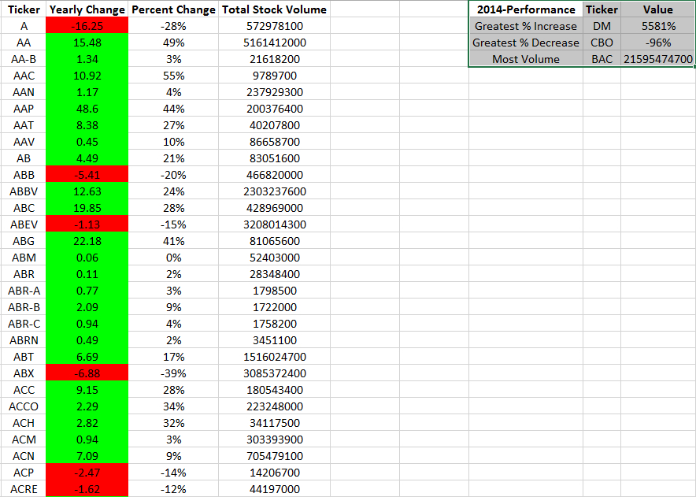

Figure 2: Final Script Output: 2014 Results

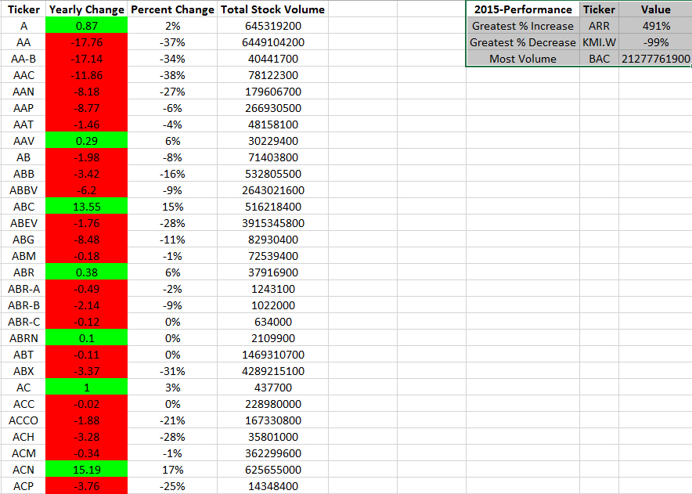

Figure 3: Final Script Output: 2015 Results

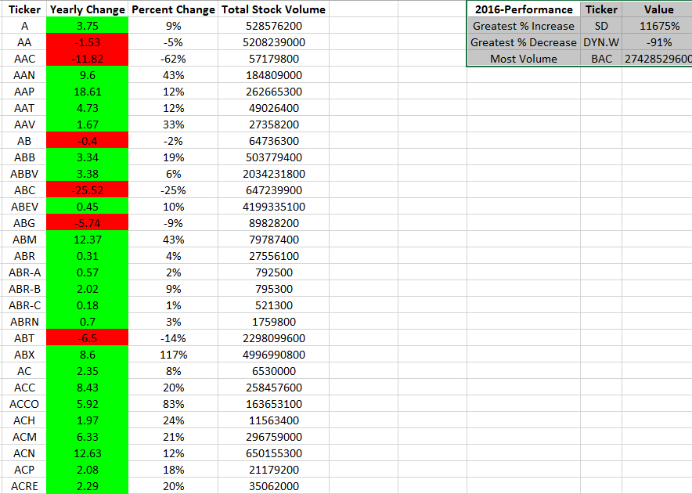

Figure 4: Final Script Output: 2016 Results